1. **CONCAT:**

Used to concatenate two or more expressions of the same type.



Verify the loaded contents:

**DUMP a;**

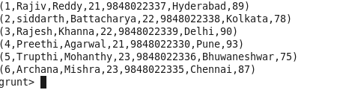

**Concatenate the fields:**



**Result:**

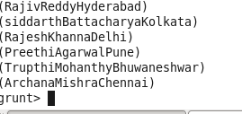

1. **SUM:**

**Data:**

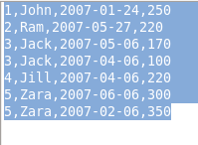

First load the data :



**To perform aggregate functions like – SUM first group the data.**



**DUMP group_data;**



**Checking the schema of grouped data:**



**Sum of all the pages typed:**





1. **MIN( )**

**Data**



Used to calculate the minimum value from a set of given numerical values. TO use min – aggregation function first we need to GROUP the values.

Running in batch mode.

Min.pig

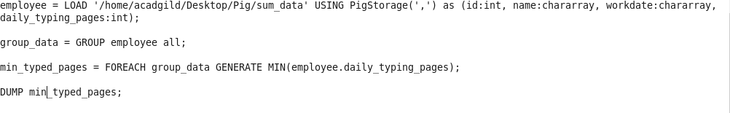

**Run the pig script – pig –x local min.pig**

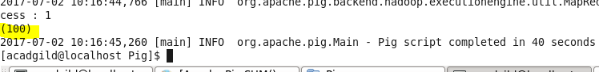

1. **MAX**

**Data**



Used to calculate the maximum value from a set of given numerical values. TO use max – aggregation function first we need to GROUP the values.

Running in **batch** mode.

**max.pig**

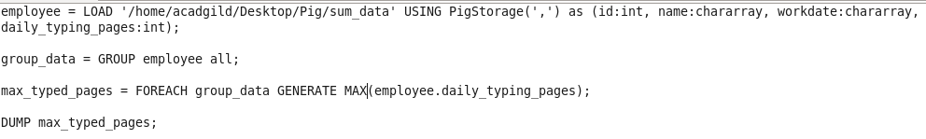

Script – pig –x local max.pig

**Result:**

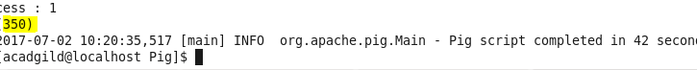

1. **LIMIT:**

To get a limited number of tuples from a relation.

Data is same as above and run in batch mode.

**Pig script:**

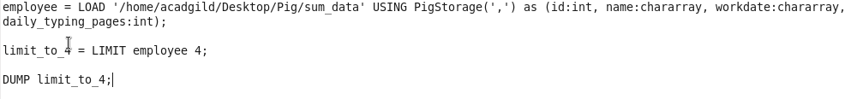

**Result:**

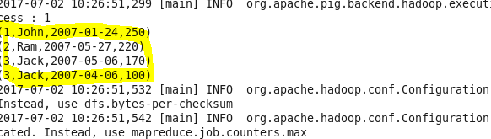

1. **DISTINCT:**

Used to remove duplicate tuples from a relation.

Data:

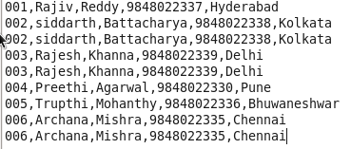

**Script:**

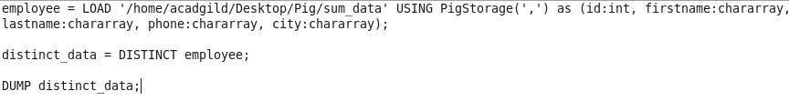

**Result:**

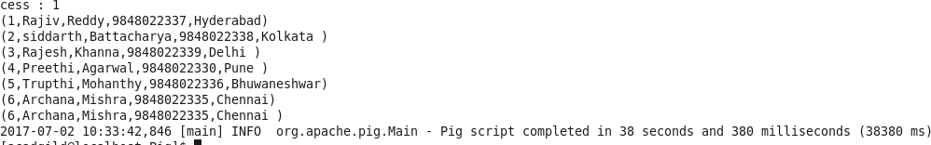

1. **STORE:**

To store the result data in HDFS or in local.

Storing result in local mode:

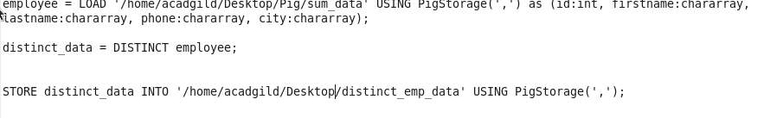

Result

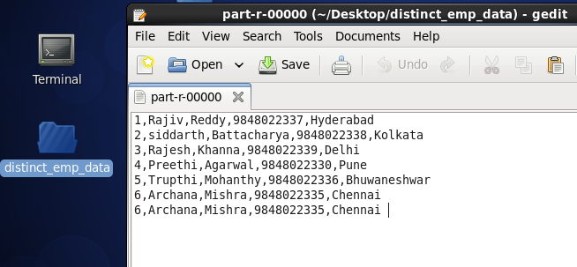

1. **IsEmpty:**

Used to check if a bag or map is empty.

Load data:

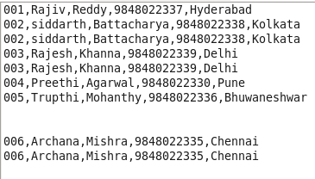

Check IsEmpty:



Result:

1. **TOKENIZE:**

Used to split a string (which contains a group of words) in a single tuple and returns a bag which contains the output of the split operation.

**Load below Data:**



**Pig script:**

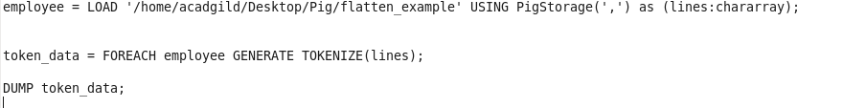

**Output:**

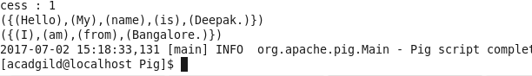

1. **FLATTEN:**

Sometimes there is data in a tuple or bag and if we want to remove the level of nesting from that data then Flatten modifier in Pig can be used. Flatten un-nests bags and tuples.

**Data:**



**Pig script:**

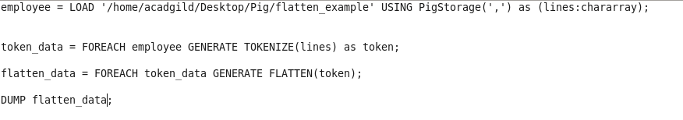

**Result:**

